# Renault Trafic Dimensions

Renault Trafic is a popular mid-size van with a two-wheel base (SWB and LWB). In this article, we are looking into the dimensions of the Renault Trafic van for all variants so that you can decide if a Renault Trafic is a suitable fit for your personal or business needs.

The Renault Trafic variants are designed so thoughtfully that they provide enough cargo space for moving goods, tools, or equipment, with the option to use as a passenger bus (minibus).

*Read our* [*Renault Trafic For Sale*](https://www.chatswoodrenault.com.au/blog/renault-trafic-for-sale-in-sydney/6096/) *and discover its prices, features, colour variation and more.*

**What are the dimensions of a Renault Trafic van?**

The short wheelbase(SWB) variant of Renault Trafic has a dimension of 5080 mm long * 1956 mm wide and 1971 mm high. And the long wheelbase(LWB) variant has a dimension of 5480 mm long, 1956 mm wide and 1971 mm high.

## 2023 Renault Trafic Dimensions Across All Variants

| **Dimensions** | **SWB Pro** | **SWB Premium** | **LWB Pro** | **LWB Premium** | **LWB Crew Pro** | **LWB Crew**  **Lifestyle** |
| --- | --- | --- | --- | --- | --- | --- |
| Renault Trafic Length (mm) | 5080 | | 5480 | | | |
| Renault Trafic Width (mm) | 2283 | | 2283 | | | |
| Renault Trafic Height (mm) | 1971 | | 1967 | | | |
| Renault Trafic Wheelbase (mm) | 3098 | | 3498 | | | |
| Renault Trafic Minimum ground clearance (mm) | 160 | | 160 | | | |

Let’s get a clear idea by looking at the drawings below to get a clear idea about the dimensions of Renault Trafic variants.

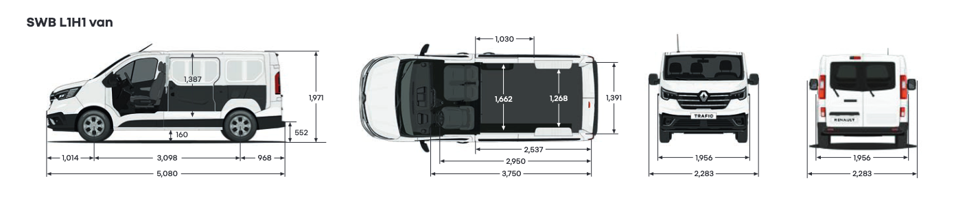

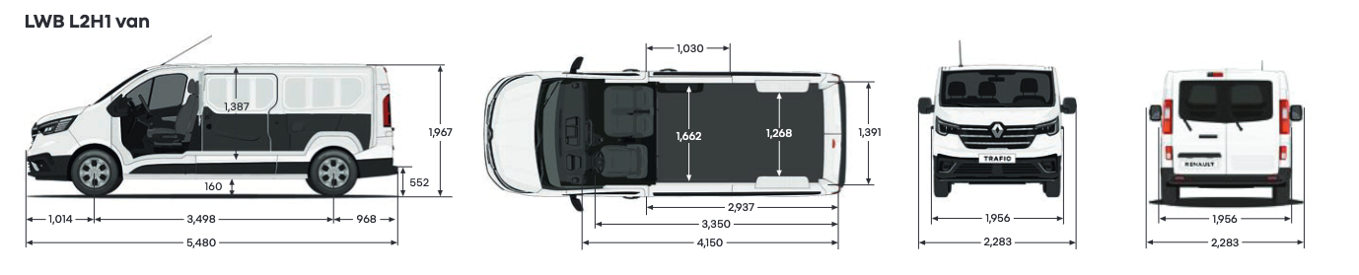

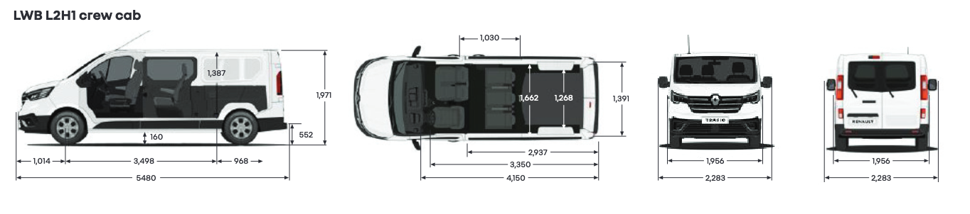

## Renault Trafic for sale on Chatswood Renault

Now that you know the dimension of every variant, why not take a look at the vans we have on sale and take it for a test ride?

[](https://www.chatswoodrenault.com.au/stock/all-cars-for-sale/Renault/Trafic)

## FAQs

### How tall is a Renault Trafic van in meters?

The height of Renault Trafic vans ranges from 1967 mm to 1971 mm.

### How big is the back of a Renault Trafic?

All variants of Renault Trafic have a maximum cargo bay width of 1268 mm and 1622 mm cargo bay width between wheel arches.

### What is the towing capacity of a Renault Trafic van? Can it tow a caravan?

The maximum towing capacity of a Renault Trafic van is 2500 kg, which can easily tow a caravan.

### How much storage space does a Renault Trafic have?

Renault Trafic can accommodate 4.3 cubic metres to 6.7 cubic metres depending on the van variant.